Paper Title
First Author¹, Second Author^{2*}, Third Author²
¹ 1st affiliation, address, e-mail address(es)
² 2nd affiliation, address, e-mail address(es)
*Corresponding Author: e-mail address

Identify applicable funding agency/ies here. If none, delete this text box. Affiliation
Abstract— These instructions are provided in the format required for the manuscript, which must be submitted in publication-ready form, including all figures and tables. The manuscript should be written in British English. The overall length of the paper should be approximately six pages (with a minimum of four). The abstract should clearly outline the scope of the paper, summarise the main results, and present the key conclusions. It should not normally exceed 150 words and must not include formulas. The abstract text should be formatted in 10-point bold font. (Abstract)
Keywords— IMEKO World Congress; Metrology; Measurement Science; Instrumentation; Uncertainty Analysis (Keywords)

INTRODUCTION (Heading 1)
This template provides authors with the formatting specifications required for the preparation of electronic versions of their papers. All standard components of the manuscript have been defined for three main reasons: (1) to facilitate ease of use in formatting individual papers; (2) to ensure automatic compliance with electronic requirements for publication; and (3) to guarantee consistency of style throughout the conference proceedings.
Margins, column widths, line spacing, and type styles are predefined. Examples of these styles are provided throughout this document and are indicated in italic type, within parentheses, following each example. Certain elements, such as multi-level equations, figures, and tables, are not strictly prescribed; however, relevant formatting guidelines are provided. Authors are responsible for formatting these elements in accordance with the instructions given.

Formatting your paper

Use of the Template (Heading 2)
The template is intended to format your paper and standardise the presentation of the text. All margins, column widths, line spacing, and font styles are predefined and must not be altered. Some layout features may appear unconventional; for instance, the top margin is deliberately larger than usual.
These specifications are intentional, as they are designed to ensure consistency across the entire conference proceedings rather than for an individual document. Authors are therefore requested not to modify any of the prescribed setting.

Manuscript Layout Requirements (Heading 2)
First, confirm that you have the correct template for your paper size. Papers must use the A4 format. Top margin must be 40 mm, bottom margin must be 25 mm, left and right margins must be 20 mm. All text must be in two-column format. Columns are to be 82 mm wide, with a 6 mm space between them. Text must be fully justified.
All pages must contain a heading starting 15 mm from the top of the page, containing the name and the place of the congress, in Times New Roman 8 pt, left-justified, as shown in the paper templates, and the logo of the Conferences.

Authors and Affiliations
List all authors using superscript numerals to indicate their respective affiliations. Author names should be written in full (first name followed by surname) and separated by commas. The corresponding superscript number should be placed immediately after each author’s name. They must be written in Times New Roman 12 pt, centred (Authors).
Affiliations must be listed below the author names and identified by the corresponding superscript numerals. Each affiliation should include the institution name, department (if applicable), full address, and e-mail address(es). Affiliations should be presented in italic font, written in Times New Roman 12 pt. (Affiliation).
For papers with multiple authors sharing the same affiliation, use the same superscript number. Ensure consistency and avoid duplicating identical affiliations.
The order of authors should reflect their contribution to the work and will be used for indexing and citation purposes.

Headings
Headings are organisational devices that guide the reader through your paper. There are two main types: component heads and text head.
Component heads identify the different sections of the paper that are not topically subordinate to each other. Examples include Acknowledgments and References; for these, the appropriate style is “Heading 0”. Use the style “Figure caption” for figure captions and “Table head” for table titles. Run-in heads, such as Abstract, require applying an additional style (e.g., italic) alongside the preset style to distinguish the heading from the main text.

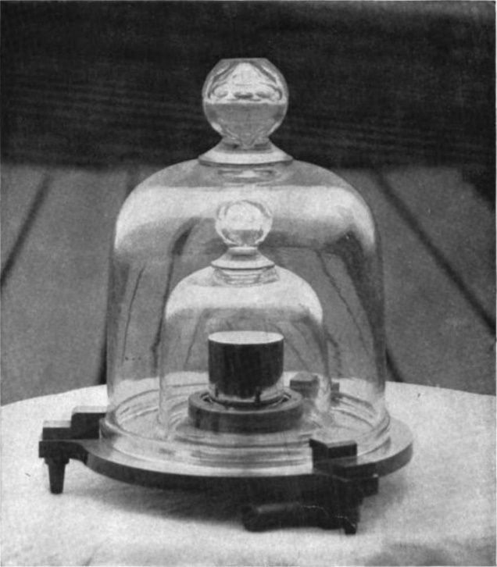
Fig. 1. A 1 kg standard mass held at the National Institute of Standards and Technology, USA. The right cylinder has a diameter and height of 39 mm and is made of an alloy of 90% platinum and 10% iridium.

Text heads organise topics hierarchically and relationally. For instance, the paper title serves as the primary text head, as all subsequent material relates to or elaborates on it. If there are two or more subtopics, the next-level headings (uppercase Roman numerals) should be used. Conversely, if there are fewer than two subtopics, no subheadings are required. Prescribed styles include Heading 1 (Uppercase Times New Roman 10 pt, with uppercase Roman numerals), Heading 2 (Times New Roman 10 pt italic, numbered with uppercase letters). Heading 3 and Heading 4 follow the predefined hierarchical styles as required”.

Figures and Tables
Figures should be centred within the column, with captions placed below each figure. Figure captions must be in Times New Roman, 9 pt, italic, and should use the abbreviation “Fig.” followed by an Arabic numeral (e.g., Fig. 1). Whenever possible, position figures at the top or bottom of columns rather than in the middle. Large figures and tables may span both columns, Fig. 2. Even at the beginning of a sentence, use the abbreviation format, for example, “Fig. 1 illustrates…”.
When labelling figure axes, use descriptive words rather than solely symbols or abbreviations to avoid confusing the reader. For example, write “Magnetization” or “Magnetization, M”, rather than just “M”. If including units, present them within parentheses immediately following the quantity. Do not label axes with units alone; for instance, use “Magnetization (A/m)” or “Magnetization (A∙m⁻¹)”, not simply “A/m”. Similarly, avoid combining quantities and units as a ratio; write “Temperature (K)” rather than “Temperature/K”.
Table I caption.
Column 1 | Column 2 | Column 3
Cell 1 | Cell 2 | Cell 3
Cell 4 | Cell 5 | Cell 6
Tables should be centred as well, with the caption positioned above the table and formatted in Times New Roman, 9 pt, italic, followed by a Roman numeral. The first row must be in Times New Roman, 9 pt, bold, while the successive in Times New Roman, 9 pt.
All figures and tables should be inserted after they are cited in the text. All figures and tables must be placed inside a frame.

Equations
Equations are an exception to the general formatting specifications of this template. Authors may use Word Equation (Insert > Equation) or external add-ins like MathType. For parameters described within the text, use the Equation editor to ensure visual consistency. Multilevel or complex equations may be inserted as high-resolution graphics if necessary.

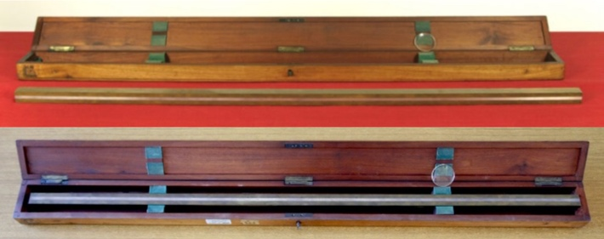

Fig 2. A 1 m standard length held at the Museo MITI.
Equations must be numbered consecutively and centered using a table-based layout. Equation numbers, enclosed in parentheses, must be flushed right within the rightmost cell of the table, as shown in equation (1):
$$A=πr^{2}$$ | (1)
To keep equations compact, use the solidus (/), the “exp” function, or appropriate exponents. as shown in equation (2):
$$v=A∙exp⁡(-E_{a}/RT)$$ | (2)
Following the VIM (International Vocabulary of Metrology) and ISO standards:
- Italicize Greek and Roman symbols when they represent variables or physical quantities (e.g., 𝜃 for angle, ρ for density, m for mass, 𝑇 for temperature).
- Use Roman (upright) font for:
  - Measurement units: (e.g., kg, m, s, Pa). Never italicize units (e.g., write kg, not kg).
  - Numerical constants: (e.g., 2, 4, π).
  - Labels or descriptors: if a subscript represents a name or a label, it must be upright. Example: $E_{\text{k}}$ (where ‘k’ stands for kinetikos), not $E_{k}$.
  - Mathematical operators: d, e, i, Δ (e.g.,d𝑥 and not dx)
  - Chemical formulas:(e.g., H₂O, CO₂, Na⁺) as shown in equation (3):
$$2{\text{H}}_{2}\text{(g)}+{\text{O}}_{2}\text{(g)}→2{\text{H}}_{2}\text{O(l)}+Δ_{\text{r}}H$$ | (3)
- Use a long dash ($-$) or the mathematical minus sign for subtractions and negative values, rather than a hyphen (-).

Units
Use SI units (MKS system) exclusively as the primary system of measurement. CGS units are generally discouraged. English or imperial units may only be used as secondary units, presented in parentheses where necessary. Exceptions are permissible when English units serve as trade identifiers, for example, “3.5-inch disk drive”.
Do not combine different unit systems within the same expression. For instance, do not mix amperes (SI) with Imperial, as this can lead to confusion and cause equations to be dimensionally inconsistent. If mixed units are absolutely unavoidable, clearly specify the units for each quantity in the equation.
Avoid mixing full spellings and abbreviations. Use either “Wb/m²” or “webers per square metre”, but not “webers/m²”. Spell out units when appearing in the text, for example: “a few henries” rather than “a few H”.
Always use a leading zero before decimal points: “0.25”, not “.25”. Use the correct SI symbols for derived units, for example, “cm³” rather than “cc”.
Ensure that all units conform to the International System of Units (SI), including the use of proper capitalisation, prefixes, and symbols, in accordance with the VIM (International Vocabulary of Metrology).
For clarity and consistency, define all non-standard or specialised quantities at their first appearance, including units, symbols, and any associated subscripts or superscripts.

Abbreviations and Acronyms
All abbreviations and acronyms must be defined the first time they appear in the text, even if they have already been defined in the abstract. This ensures clarity for readers who may skip the abstract. Commonly recognised abbreviations such as IMEKO, SI, MKS, CGS, sc, dc, and rms do not require definition.
Avoid using abbreviations in the title or section headings unless necessary. When introducing a new abbreviation, spell out the full term followed by the abbreviation in parentheses; for example: International Vocabulary of Metrology (VIM). Thereafter, the abbreviation may be used consistently throughout the text.
Ensure that all acronyms and abbreviations are used consistently, avoiding multiple variants for the same term. Do not create unnecessary abbreviations for terms that occur infrequently in the manuscript. When in doubt, prioritise clarity over brevity.

Acknowledgment (Heading 0)
Avoid formal or stilted constructions such as “one of us (R. B. G.) thanks …”; instead, use a direct phrasing, for example, “R. B. G. thanks …”. Any sponsorship or funding acknowledgments should be placed in an unnumbered footnote on the first page of the manuscript.

References
The template will number citations consecutively within square brackets [1-2]. Punctuation should follow the bracket [3-5]. Refer to the reference number directly in the text, for example: [6]; do not use “Ref. [7]” or “reference [7]”, except at the beginning of a sentence: “Reference [7] was the first …”. References must be in Times New Roman 8 pt
Footnotes should be numbered separately in superscript and placed at the bottom of the column in which they are cited. Do not include footnotes in the abstract or in the reference list. Use letters for table footnotes.
Unless a paper has six or more authors, list all authors; do not use “et al.”. Papers that have not been published, even if submitted, should be cited as “unpublished”. Papers that have been accepted for publication should be cited as “in press”. Capitalise only the first word in a paper title, except for proper nouns and element symbols. For papers published in translation journals, provide the English citation first, followed by the original foreign-language citation.
Authors are encouraged to prioritise citations from these journals to ensure relevance to the Metrology and Measurement field. Non-exhaustive examples of such journals include:
- Measurement (Elsevier)
- Measurement: (Sensors, Energies, Food, Digitalization)
- ACTA IMEKO
- IEEE Transactions on Instrumentation and Measurement
- IEEE Open Journal of Instrumentation and Measurement
- IEEE Instrumentation and Measurement Magazine
- Metrologia
- Metrology and Measurement Systems
- Measurement Science and Technology
- Review of Scientific Instruments
- Measurement Science Review
- Journal of Instrumentation
- Instrumentation Science & Technology
- Instruments and Experimental Techniques
- Measurement Techniques
- Nuclear Instruments and Methods in Physics Research, Sections A and B
- Atmospheric Measurement Techniques
- Physiological Measurement
- Journal of Dynamic Systems, Measurement, and Control
- Radiation Measurements
- Flow Measurement and Instrumentation
- IET Science, Measurement & Technology

- O. Kovac, A. Kovacova, J. Saliga, J. Kromka, P. Daponte, L. De Vito, F. Picariello, S. Rapuano, and I. Tudosa, “A CS-based measurement method for impedance estimation of induction motor coil,” Measurement, vol. 259, pt. A, Art. no. 119586, 2026, doi: 10.1016/j.measurement.2025.119586.
- A. Moschitta, A. Comuniello, A. De Angelis, F. Santoni, and P. Carbone, “Effect of noise, partial synchronization, and sampling frequency inaccuracies on amplitude measurement of multiple linear chirp signals,” Measurement, vol. 181, Art. no. 109635, 2021, doi: 10.1016/j.measurement.2021.109635.
- L. Apa, L. D’Alvia, Z. Del Prete, and E. Rizzuto, “A characterization of the uncertainties associated with an automated system for the study of lithium-ion cells: A case-study of a domestic grid 24-h scenario,” IEEE Trans. Instrum. Meas., vol. 73, Art. no. 1503811, pp. 1–11, 2024, doi: 10.1109/TIM.2024.3476559.
- M. G. Cox, G. B. Rossi, P. M. Harris, and A. Forbes, “A probabilistic approach to the analysis of measurement processes,” Metrologia, vol. 45, no. 5, 2008, doi: 10.1088/0026-1394/45/5/001.
- M. D’Apuzzo, M. D’Arco, A. Liccardo, and M. Vadursi, “Method for measuring settling phenomena by means of frequency domain instrumentation,” Rev. Sci. Instrum., vol. 87, Art. no. 055103, 2016, doi: 10.1063/1.4948296.
- A. Zienkiewicz, M. Favre, H. Ferdinando, S. Iring, J. Serrador, and T. Myllylä, “Blood pressure wave propagation—a multisensor setup for cerebral autoregulation studies,” Physiol. Meas., vol. 42, no. 11, Art. no. 115007, 2021, doi: 10.1088/1361-6579/ac3629.

